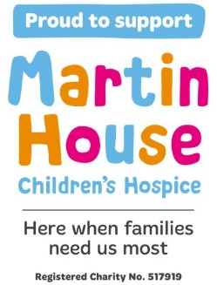**CITY of LEEDS MG & CLASSIC CAR SHOW**

Supporting Martin House Childrens Hospice.

**Grange Park Wetherby LS22 5DY**

**ENTRY FORM**

**Saturday 20th July 2024**

**10.00am – 4.00pm**

**All Makes Welcome – Open to all Pre 2005 cars.**

|  |  |  |  |
| --- | --- | --- | --- |
| Name |  | | |
| Address |  | | |
| Postcode |  | | |
| Email |  | | |
| Phone |  | Mobile |  |

**Vehicle Details**

|  |  |  |  |  |
| --- | --- | --- | --- | --- |
| Make |  | | Model |  |
| Colour |  | | Year |  |
| Registration Number | |  | | |
| Club Name (if part of a club) | |  | | |

**If you are entering Concours D’Elegance – Please Tick Here.**

**All Concours D’Elegance entries must be submitted by 13th July 2024.**

**and must be on site no later than 10-30 am on 20th July 2024.**

**Please send your completed form with your voluntary donation made payable to**

**Martin House Childrens Hospice with a stamped addressed envelope for your entry pass to**

Wetherby CCS

4 Farnham Close

Leeds

LS14 2HS.

**Suggested Minimum Donation £5.00**

**If you Wish to Gift Aid Your Donation – Please Tick This Box**

I am a UK taxpayer, and I would like Martin House Childrens Hospice to reclaim the tax on all donations

I have made in the last 4 years and for all future donations of money that I make to be Gift Aid donations.

I understand that if I pay less Income Tax and/or Capital Gains Tax than the amount of Gift Aid claimed on all my donations in that tax year, it is my responsibility to pay any difference.