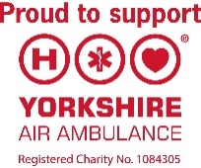
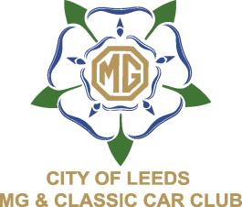
CITY of LEEDS MG & CLASSIC CAR CLUB
Supporting the Yorkshire Air Ambulance.
TADCASTER CLASSIC CAR SHOW
ENTRY FORM
Sunday 12th May 2024
10.00am – 3.00pm
All Makes Welcome – Open to all Pre 2000 cars.
VENUE: John Smiths Brewery Car Park Tadcaster LS24 9HD
Name
Address
Postcode
Email
Phone |  | Mobile
Vehicle Details
Make |  |  | Model
Colour |  |  | Year
Registration Number
Club Name (if part of a club)

If you are entering Concours D’Elegance – Please Tick Here.
All Concours D’Elegance entries must be submitted by 5th May 2024.
and must be on site no later than 11.00am on 12th May 2024.

Please send your completed form with your voluntary donation made payable to

Yorkshire Air Ambulance with a stamped addressed envelope for your entry pass to

Tadcaster CCS
4 Farnham Close
Leeds
LS14 2HS.

If you Wish to Gift Aid Your Donation – Please Tick This Box

I am a UK taxpayer, and I would like Yorkshire Air Ambulance to reclaim the tax on all donations.
I have made in the last 4 years and for all future donations of money that I make to be Gift Aid donations.

I understand that if I pay less Income Tax and/or Capital Gains Tax than the amount of Gift Aid claimed on all my donations in that tax year, it is my responsibility to pay any difference.

